FORMAT OF BIODATA

Prerana Vilas Hegade  Address: Bapu Niwas,Dattawadi,Akurdi,Pune 411035 | 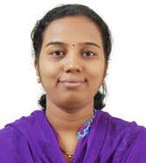

Designation: Lecturer

Educational Qualification: B.com, MBA (Finance) & G.D.C.A.

Teaching Experience: 28 August 2016 till date
5 years as Visiting Faculty for M.B.A.

Classes Taught: F.Y.BBA, S.Y.BBA, T.Y.BBA, F.Y.BBA (C.A)

Seminars/Workshops/ Training courses attended:
- Workshop on Research Proposal & research Paper Writing.
- Training by MSME Development institute Mumbai under programme of
“Management development programme on industrial Management.”

Participation in community/ Social Services:
- Participated in Employee safety workshop at Vishwas Enterprise.
- Participated in E-Literacy Program at Yelghol.

Computer Skills:
- Tally ERP
- MS- CIT

